Name _________________________________________________

What is the name of your fruit?

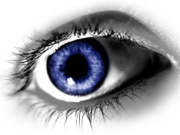What does it look like?

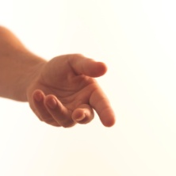What does it feel like?